Save the Date, Join the Committee
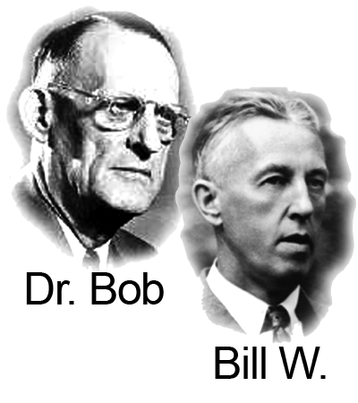
2026 Founders Day
Hosted by Maricopa County-District 08
June 13, 2026-Saturday
9:00am to 3:00pm
Camelback Bible Church
3900 E Stanford Dr.
Paradise Valley, AZ 85253

Get Involved, Have Some Fun, Be of Service
Contacts: Michelle G.-District Coordinator
480.370.5672 Mopearl3@gmail.com
Shelby R.- Event Chairperson 602.554.2373

